**­­­­­**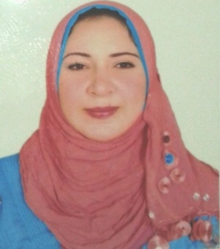

**Curriculum Vitae**

**Personal Information**:

|  |  |  |  |  |  |  |  |  |  |  |  |  |  |  |  |  |
| --- | --- | --- | --- | --- | --- | --- | --- | --- | --- | --- | --- | --- | --- | --- | --- | --- |
| |  |  | | --- | --- | |  | | | Name: | Mona Hassan Ahmed Sawy | | Faculty: | Arts | | Department: | Archaeology | | E-mail: | Sawy_mona@yahoo.com | | Phone: | 0882371800 | |  |  | | Mobile: | 01014902598 | |

|  |
| --- |
| **Qualifications:** |
| | **Qualification** | **University** | **Country** | **Year** | | --- | --- | --- | --- | | Masters | Assuit University | Assuit-Egypt | 2012 | | Bachelor | Assuit University | Assuit-Egypt | 2008 | |

**1**

**Education:**

|  |
| --- |
| **Name of University:** Assuit University, Faculty of Arts |
| **Major :** Archaeology department |
| **Minor :** Coptic language |
| **Year :** 2008 |

**Training Sessions:**

|  |  |  |
| --- | --- | --- |
| **Name of session** | **Session place** | **Session Period** |
| 1. Coptic language. 2. Archeological survey and excavations in Archaeological locations and the Documentation of Archaeological properties. 3. Coptic Icons in Ritual, literature and history. | [Bait Al Sinnari](https://twitter.com/BaytAlSinnari)- Cairo  Assuit University, Faculty of Arts  Monastery of Our Lady of Carmel Bulaq Abou El Ela- Cairo | 10-10-2011 to 10-12-2011  7-11-2010 to 8-11-2010  11-6-2013 to 15-6-2013 |

**Academic Positions:**

* (March 2009) Demonstrator at Assuit University, faculty of Arts.
* (December 2012) Assistant lecturer of Coptic language, Assuit University, faculty of Arts.

**2**

**Publications:**

|  |
| --- |
| 1**- " *Types of loan in Ancient Egypt (Coptic period)***" (forthcoming)  11th International Congress of Egyptologists in Alexandria, 13th-20th September 2013.  2- ***"Coptic Debt contract from Nubia" A linguistic and cultural study"***(forthcoming)  Graduate Annual Research Discussions on Egypt and Nubia (GARDEN). |

**Skills:**

|  |  |  |  |
| --- | --- | --- | --- |
| |  |  | | --- | --- | |  |  |  Technical Skills  * [**Computing skills**](http://www.kent.ac.uk/careers/sk/ComputingSkills.htm) | I am now proficient in all aspects of Microsoft Windows and Office including Excel, Access and PowerPoint. Good knowledge of BASIC programming, MS Windows XP and MS Word**.** |
| * **Languages** | * High Skills in speaking, reading & written English. * Intermediate French and German. * High skills in Ancient Egyptian languages as Hieroglyphs, Hieratic and Coptic language. |

**3**